该程序主要特点： 流程组件都是独立的，流程组件都是异步执行的但有顺序的遵循FIFO,流程组件共享数据上下文。

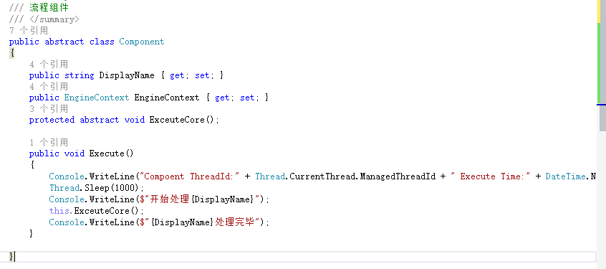

上下文信息

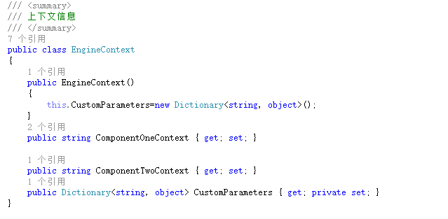

数据处理

public class DataFlowService

{

private EngineContext _engineContext;

private ActionBlock<Component> compenentActionBlock = new ActionBlock<Component>(c =>

{

c.Execute();

});

public DataFlowService(EngineContext engineContext)

{

this.FlowComponentList = new List<Component>();

this._engineContext = engineContext;

}

public List<Component> FlowComponentList { get; private set; }

public DataFlowService AddComponent(Component component)

{

component.EngineContext = _engineContext;

this.FlowComponentList.Add(component);

return this;

}

public EngineContext EngineContext

{

get { return _engineContext; }

}

public void PostData()

{

foreach (var component in FlowComponentList)

{

compenentActionBlock.Post(component);

}

compenentActionBlock.Complete();

compenentActionBlock.Completion.Wait();

}

}

客户端调用

  public class PriceTaxSplitCompoent : Component

    {

        public PriceTaxSplitCompoent()

        {

            this.DisplayName = "价税分离";

        }

        protected override void ExceuteCore()

        {

            EngineContext.ComponentOneContext = "价税分离处理完毕";

        }

    }

    public class DetailMergeCompoent : Component

    {

        public DetailMergeCompoent()

        {

            this.DisplayName = "同类明细合并";

        }

        protected override void ExceuteCore()

        {

            EngineContext.ComponentOneContext = "价税分离上下文信息在同类明细合并进行了变更";

            EngineContext.ComponentTwoContext = "同类明细合并完成";

        }

    }

    class Program

    {

        static void Main(string[] args)

        {

            Console.WriteLine("Main ThreadId:" + Thread.CurrentThread.ManagedThreadId + " Execute Time:" + DateTime.Now);

            EngineContext engineContext=new EngineContext();

            DataFlowService dataFlowService=new DataFlowService(engineContext);

            dataFlowService.AddComponent(new PriceTaxSplitCompoent()).AddComponent(new DetailMergeCompoent());

            dataFlowService.PostData();

            Console.WriteLine("数据处理完毕");

        }

    }

执行结果